**Brachial plexus segmentation on ultrasound imaging with a deep learning model for neuraxial blockade**

**RESEARCH PROTOCOL**

**Version 1.0 (26-01-2021)**

**Brachial plexus segmentation on ultrasound imaging with a deep learning model for neuraxial blockade**

|  |  |
| --- | --- |
| **Short title** | Brachial plexus U-net |
| **Version** | 1.0 |
| **Date** | 26-01-2021 |
| **Co-investigators** | E. Dortangs, MD  Elisabeth-TweeSteden Ziekenhuis (ETZ) Department of Anesthesiology Hilvarenbeekseweg 60 5022 GC Tilburg, The Netherlands  Telephone: +31 (0)13 221 0000 E-mail: E.Dortangs@etz.nl  G. van der Veen, MD  Radboudumc Department of Anesthesiology Geert Grooteplein Zuid 10 6525 GA Nijmegen, The Netherlands  Telephone: +31 (0)24 361 1111 E-mail: Gijs.vanderVeen@radboudumc.nl |
| **Principal investigator** | R.C. Tolboom, MD  Radboudumc Department of Anesthesiology Geert Grooteplein Zuid 10 6525 GA Nijmegen, The Netherlands  Telephone: +31 (0)24 361 1111 E-mail: Rob.Tolboom@radboudumc.nl |
| **Sponsor** | Radboudumc Department of Anesthesiology Geert Grooteplein Zuid 10 6525 GA Nijmegen, The Netherlands |
| **Subsidising party** | Not applicable |
| **Independent expert(s)** | Not applicable |

**PROTOCOL SIGNATURE SHEET**

|  |  |  |
| --- | --- | --- |
| **Name** | **Signature** | **Date** |
| **Co-investigators**  E. Dortangs, MD  Elisabeth-TweeSteden Ziekenhuis (ETZ) Department of Anesthesiology Hilvarenbeekseweg 60 5022 GC Tilburg, The Netherlands  Telephone: +31 (0)13 221 0000 E-mail: E.Dortangs@etz.nl  G. van der Veen, MD  Radboudumc Department of Anesthesiology Geert Grooteplein Zuid 10 6525 GA Nijmegen, The Netherlands  Telephone: +31 (0)24 361 1111 E-mail: Gijs.vanderVeen@radboudumc.nl |  |  |
| **Principal investigator**  R.C. Tolboom, MD  Radboudumc Department of Anesthesiology Geert Grooteplein Zuid 10 6525 GA Nijmegen, The Netherlands  Telephone: +31 (0)24 361 1111 E-mail: Rob.Tolboom@radboudumc.nl |  |  |
| **Sponsor**  Prof. dr. Malagon  Radboudumc Department of Anesthesiology Geert Grooteplein Zuid 10 6525 GA Nijmegen, The Netherlands |  |  |

**TABLE OF CONTENTS**

1. INTRODUCTION AND RATIONALE 8

2. OBJECTIVES 9

3. STUDY DESIGN 10

3.1 Population (base) 12

3.2 Inclusion criteria 12

3.3 Exclusion criteria 12

4. TREATMENT OF SUBJECTS 13

5. METHODS 14

5.1 Study parameters/endpoints 14

5.1.1 Main study parameter/endpoint 14

5.1.2 Secondary study parameters/endpoints (if applicable) 14

5.2 Study procedures 14

5.3 Withdrawal of individual subjects 14

5.4 Replacement of individual subjects after withdrawal 14

5.5 Follow-up of subjects withdrawn from treatment 14

6. STATISTICAL ANALYSIS 15

7. SAFETY REPORTING 16

7.1 Section 10 WMO event 16

7.2 AEs, SAEs and SUSARs 16

7.2.1 Adverse events (AEs) 16

7.2.2 Serious adverse events (SAEs) 16

7.3 Follow-up of adverse events 17

8. ETHICAL CONSIDERATIONS 18

8.1 Regulation statement 18

8.2 Recruitment and consent 18

8.3 Compensation for injury 18

9. ADMINISTRATIVE ASPECTS, MONITORING AND PUBLICATION 19

9.1 Handling and storage of data and documents 19

9.2 Amendments 19

9.3 Annual progress report 19

9.4 End of study report 19

9.5 Public disclosure and publication policy 19

**LIST OF ABBREVIATIONS AND RELEVANT DEFINITIONS**

|  |  |
| --- | --- |
| **ABR** | **ABR form, General Assessment and Registration form, is the application form that is required for submission to the accredited Ethics Committee (In Dutch, ABR = Algemene Beoordeling en Registratie)** |
| **AE** | **Adverse Event** |
| **AR** | **Adverse Reaction** |
| **CCMO** | **Central Committee on Research Involving Human Subjects; in Dutch: Centrale Commissie Mensgebonden Onderzoek** |
| **CV** | **Curriculum Vitae** |
| **DSMB** | **Data Safety Monitoring Board** |
| **EU** | **European Union** |
| **GCP** | **Good Clinical Practice** |
| **GERD** | **Gastroesophageal reflux disease** |
| **IC** | **Informed Consent** |
| **METC** | **Medical research ethics committee (MREC); in Dutch: medisch ethische toetsing commissie (METC)** |
| **PPI** | **Protonpumpinhibitor(s)** |
| **(S)AE** | **(Serious) Adverse Event** |
| **Sponsor** | **The sponsor is the party that commissions the organisation or performance of the research, for example a pharmaceutical company, academic hospital, scientific organisation or investigator. A party that provides funding for a study but does not commission it is not regarded as the sponsor, but referred to as a subsidising party.** |
| **SUSAR** | **Suspected Unexpected Serious Adverse Reaction** |
| **Wbp** | **Personal Data Protection Act (in Dutch: Wet Bescherming Persoonsgevens)** |
| **WMO** | **Medical Research Involving Human Subjects Act (in Dutch: Wet Medisch-wetenschappelijk Onderzoek met Mensen** |

**SUMMARY**

**Rationale**

A failed nerve block not only results in a bad experience for the patient, it might even lead to damage to the patients’ health and in some cases complications could even threaten life.

It’s essential to recognise ultrasound anatomy when performing nerve blocks, however this may sometimes be hampered by patients’ habitus.

A possible solution might be the recent rise in artificial intelligence, especially deep learning. Nowadays, deep learning is being used in all walks of life. Facial recognition systems are being made, Google knows what objects are on your photos and manages to classify them correctly.

**Objective**

In this study we will attempt to create a dataset of ultrasound images depicting the brachial plexus and use this dataset to train an U-net model in order to identify the region of interest in these images, which may potentially be used in clinical practise.

Primary Objective

1. Construct a dataset of ultrasound images depicting the brachial plexus with manual image segmentation

Secondary Objective(s)

1. Train an U-net deep learning model using the dataset and teach it to properly identify the brachial plexus

**Study design**

We will prospectively collect 500 ultrasound images of 250 healthy adults by contacting colleagues in both hospitals, requesting their participation in this study. Ultrasound images of both the left and right brachial plexus will be obtained with an on-screen orientation where left equals lateral.

We will then feed the ultrasound images to the U-net model and set the manually marked masks (of the brachial plexus) as the output segmentation map to train the model.

**Study population**

Healthy adults with intact brachial plexus without previous surgery or radiotherapy in the area.

**Main study parameters/endpoints:**

Dataset creation

* 500 ultrasound images of the supraclavicular region with segmentation

U-net model creation

- Intersection over union per image (see Eq 1.)

- Model accuracy (see Eq 2.)

- Ultrasound images with brachial plexus segmented by the machine learning model

**Nature and extent of the burden and risks associated with participation, benefit and group relatedness:**

This study is associated with no risk to the subjects’ wellbeing.

# INTRODUCTION AND RATIONALE

Regional nerve block is a common anaesthesia technique used for surgery on the extremities. A successful block requires excellent anaesthesia experience including the ability to identify the appropriate nerves and surrounding tissues on ultrasound and good skills with a needle.

Previous studies have primarily focussed on the usage of ultrasound which has shown that ultrasound increases the success rate of regional nerve blocks. Some studies, however, have found that even with ultrasound assistance, a relatively high failure rate persists. This failure rate has largely been attributed to operators with limited experience and insufficient ultrasound skills.

A failed nerve block not only results in a bad experience for the patient, it might even lead to damage to the patients’ health and in some cases complications could even threaten life.

It’s essential to recognise ultrasound anatomy when performing nerve blocks, however this may sometimes be hampered by patients’ habitus.

A possible solution might be the recent rise in artificial intelligence, especially deep learning. Nowadays, deep learning is being used in all walks of life. Facial recognition systems are being made, Google knows what objects are on your photos and manages to classify them correctly.

Previously several studies have tried to apply this computer vision, a part of deep learning, on medical images. In 2016 a competition was held in recognizing the brachial nerve with limited success.

Some years later, in 2019, Huang et al attempted to train a U-net model with ultrasound images of the femoral nerve region and managed to successfully create images with segmentation applied.

# OBJECTIVES

In this study we will attempt to create a dataset of ultrasound images depicting the brachial plexus and use this dataset to train an U-net model in order to identify the region of interest in these images, which may potentially be used in clinical practise.

Primary Objective

1. Construct a dataset of ultrasound images depicting the brachial plexus with manual image segmentation

Secondary Objective(s)

1. Train an U-net deep learning model using the dataset and teach it to properly identify the brachial plexus

# STUDY DESIGN

We will prospectively collect 500 ultrasound images of 250 healthy adults, annotate them (brachial plexus segmentation) and then attempt to train a deep learning model (U-net).

Several dates (to be determined) will be selected where the researchers will set up the ultrasound machine and allow walk-in study enrollment. When approached by a prospective study participant, the researcher shall first present him or her the study information form. After the prospective participant is sufficiently informed and has no questions regarding study participation, an informed consent form will be presented to be signed.

After informed consent is obtained, the volunteer will be asked to take place on a chair and expose the area above the left clavicle to enable ultrasound imaging. After the left brachial plexus has been visualized, the volunteer will be asked to expose the right clavicle in order to visualize the other side. There is no need for volunteers to remove their clothes. Total time of this procedure is estimated at 5 minutes maximum.

While visualizing the brachial plexus, special care needs to be taken by the researcher to assure that the left side on the ultrasound monitor equals the lateral side in the patient.

For each volunteer, two ultrasound images (left and right brachial plexus) will be stored on the ultrasound machine itself under a randomly generated temporary identification number. At the end of the day, all images obtained will be extracted from the ultrasound machine as RGB images (which means each image has three colour channels).

After verification by three independent researchers to ensure that the brachial plexus is clearly identifiable, all ultrasound images are automatically edited: the peripheral part of the ultrasound image that is not depicting any tissue is removed. Next the image is converted to grayscale (1 colour channel).

Once collection of all ultrasound images is complete, the now fully anonymized dataset is uploaded to “the Grand Challenge”, an online platform for end-to-end development for machine learning solutions in biomedical imaging (grand-challenge.org).

Using the Grand Challenge platform, experienced physicians will then use the build-in image segmentation tools to annotate each individual ultrasound image of the brachial plexus. This annotation is then verified by the two other researchers independently as quality assurance.

When comparing the image segmentation masks, any IoU (intersection over union) ≤ 90% is deemed insufficient and will lead to determination of the true plexus in a consensus meeting with all three researchers present.

For the model training process, we selected the U-net model to train our data. U-net is a widely used network used for biomedical image segmentation. Its architecture is shown below (Fig 1).

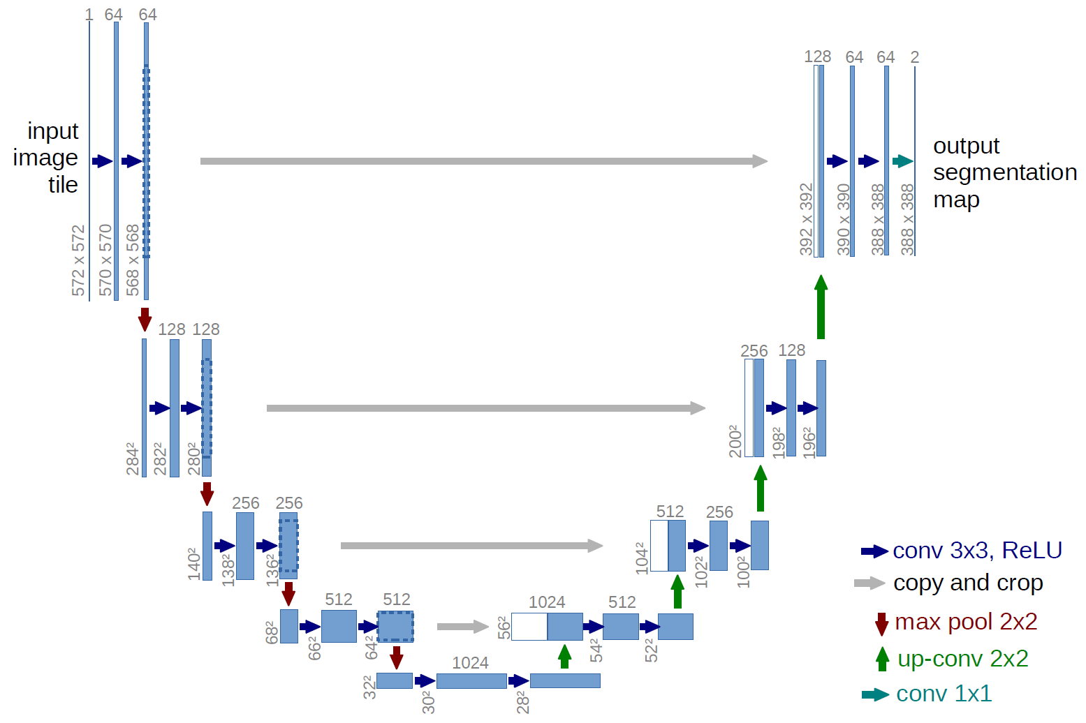

**Fig 1**. Simplified architecture of U-net. The vertical line and rectangles refer to the input, convolved and output images. The convolution kernels are summarized in the right bottom. Conv, convolution; ReLU, rectified linear unit.

The input image is convolved by multiple layers and extracted to numbers of features, which are then deconvolved and added to the convolved images in shallow layers. Finally, the image size of the output layer is the same as that of the input layer. The framework is just like the word ‘U’, which is where its name comes from.

We will feed the ultrasound images to the input layer and set the manually marked masks as the output segmentation map to train the model.

For this purpose, our dataset will be split into a training set, the development set and the test set. Only the training set will be used to fit the model; the development set is for validation during the fitting process; and the test set is for evaluating the model.

The segmentation quality will be evaluated by using the intersection over union (IoU) metric which is defined as Eq. 1. The intersection the area of overlap between the predicted mask and manual mask, while the union refers to the combination of these two masks (Figure 2). We shall consider an IoU >0.5 to be an effective segmentation, leading to a model accuracy defined as Eq 2.

**Eq. 1 Eq. 2**

$IoU=\frac{Intersection}{Union}$ $Accuracy=\frac{Number of images with IoU>0.5}{Total number of images}*100\%$

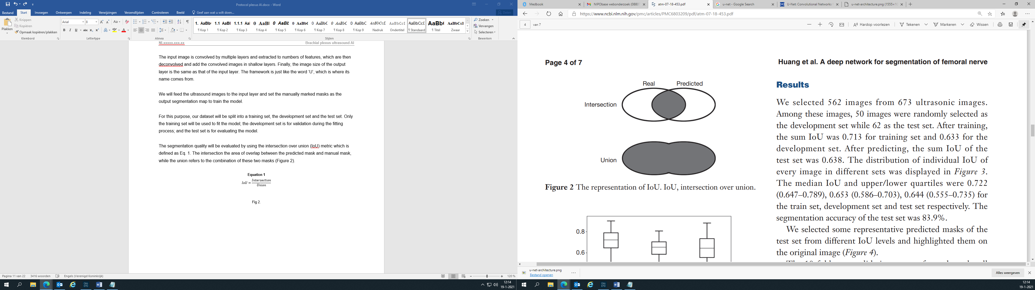

**Fig 2**. The representation of IoU. IoU, intersection over union.

STUDY POPULATION

## Population (base)

The patient population will consist of healthy adults without severe obesity and previous surgery or radiotherapy near the brachial plexus.

Once the inclusion phase of this trial commences, all researchers will present this study at their workplace and request study participation.

No advertisements will be made nor published. No recruitment campaigns will be held. We estimate to find sufficient participants solely by word of mouth.

Several dates (to be determined) will be selected where the researchers will set up the ultrasound machine and allow walk-in study enrollment. When approached by a prospective study participant, the researcher shall first present him or her the study information form. After the prospective participant is sufficiently informed and has no questions regarding study participation, an informed consent form will be presented to be signed.

## Inclusion criteria

- Adult (age ≥ 18)

## Exclusion criteria

- BMI ≥ 30

- Previous surgery near the brachial plexus

- History of radiotherapy at or near the brachial plexus

- Inability to understand the Dutch language

- Inability to understand and/or fill in the informed consent

# TREATMENT OF SUBJECTS

After informed consent is obtained, the volunteer will be asked to take place on a chair and expose the area above the left clavicle to enable ultrasound imaging. After the left brachial plexus has been visualized, the volunteer will be asked to expose the right clavicle in order to visualize the other side. There is no need for volunteers to remove their clothes. Total time of this procedure is estimated at 5 minutes maximum.

# METHODS

## Study parameters/endpoints

### Main study parameter/endpoint

Dataset creation

* 500 ultrasound images of the supraclavicular region with segmentation

### Secondary study parameters/endpoints (if applicable)

U-net model creation

* Intersection over union per image (see Eq 1.)
* Model accuracy (see Eq 2.)
* Ultrasound images with brachial plexus segmented by the machine learning model

## Study procedures

Brachial plexus ultrasound

A Philips Sparq Ultrasound Machine with the L12-4 linear array transducer will be used to identify the brachial plexus in all patients. For this examination, the factory build-in preset “Nerve 0-4cm” preset will be used with an initial depth of 3,5cm with focus set on the second quarter from below. Extra care will be taken to ensure that the left side on the monitor corresponds with the lateral side of the patient. Depth and focus will be adjusted as needed.

Each test subject’s ultrasound images will be stored on the ultrasound machine under a randomly generated temporary (anonymous) ID. For each subject, a static image of both the left and right brachial plexus will be saved. There will be no subject identification log.

## Withdrawal of individual subjects

Subjects can leave the study at any time for any reason if they wish to do so without any consequences. Due to the absence of a subject identification log and the nature of the ultrasound images (completely anonymous), patient withdrawal will not result to the removal of ultrasound images from the larger dataset as it will be impossible to identify which ultrasound image belongs to which test subject.

## Replacement of individual subjects after withdrawal

Patients that have withdrawn will not be replaced.

## Follow-up of subjects withdrawn from treatment

Not applicable.

# STATISTICAL ANALYSIS

Not applicable.

# SAFETY REPORTING

Not applicable.

# ETHICAL CONSIDERATIONS

## Regulation statement

This trial will be conducted according to the principles of the Declaration of Helsinki (Fortaleza, October 2013) and in accordance with the Medical Research Involving Human Subjects Act (WMO). Study design and procedures will be carried out in accordance with the ICH Good Clinical Practise (GCP) guidelines.

## Recruitment and consent

The information offered to the patient will contain:

* A full and fair explanation of the procedures to be followed.
* A full explanation of the nature, expected duration and purpose of the study.
* A description of any reasonable foreseeable risks or discomfort to the patient.
* A description of any benefits which may reasonably be expected.
* A statement that all patient data will be handled with care and confidentiality.
* A statement that participation is voluntary, that refusal to participate will involve no penalty or loss of benefits to which the test subject is otherwise entitled, and that the test subject may discontinue participation at any time without penalty.
* Test subjects are given time to decide whether or not to participate in the study.

## Compensation for injury

Due to the design of the study, and neglectable risks associated with study participation, an exemption on the need for insurance is requested from the medical ethics committee.

# ADMINISTRATIVE ASPECTS, MONITORING AND PUBLICATION

## Handling and storage of data and documents

At the end of any day with subject inclusions, the local researcher is tasked with exporting the ultrasound image files to an USB disk drive. Upon export, these files can be considered anonymized due to the lack of identifying features in the ultrasound image and lack of identifiable metadata.

After exporting the images from the ultrasound machine, the data is added to a secure network folder on the hospital network.

Once collection of all ultrasound images is complete, the now fully anonymized dataset is uploaded to “the Grand Challenge”, an online platform for end-to-end development for machine learning solutions in biomedical imaging (grand-challenge.org). This platform will be used to safely store the medical images for a minimum period of 15 years.

## Amendments

Not applicable.

## Annual progress report

Not applicable.

## End of study report

Not applicable.

## Public disclosure and publication policy

The results of this research will be submitted for publication to peer-reviewed, preferably open-access, scientific journals.

All code and algorithms will be published alongside the aforementioned publication.